ASSIGNMENT-01
NAME:NAYINI KALYAN REDDY
ENROLL NO:2403A54074
BATCH NO-03
Task 0
- Install and configure GitHub Copilot in VS Code. Take screenshots of each step.
Expected Output
- Install and configure GitHub Copilot in VS Code. Take screenshots of each step.
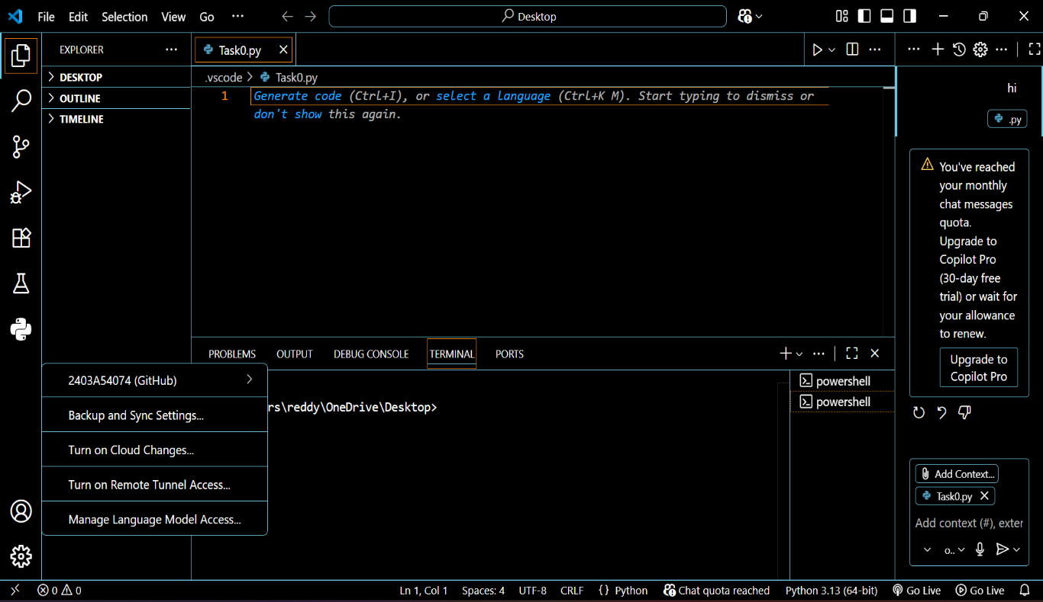

Task 1: Factorial without Functions
- Description:
Use GitHub Copilot to generate a Python program that calculates the factorial of a number without defining any functions (using loops directly in the main code).
- Expected Output:
  - A working program that correctly calculates the factorial for user-provided input.
  - Screenshots of the code generation process.
prompt : Write a python program code which takes a input from the user to find the factorial of the input ,without using any functions

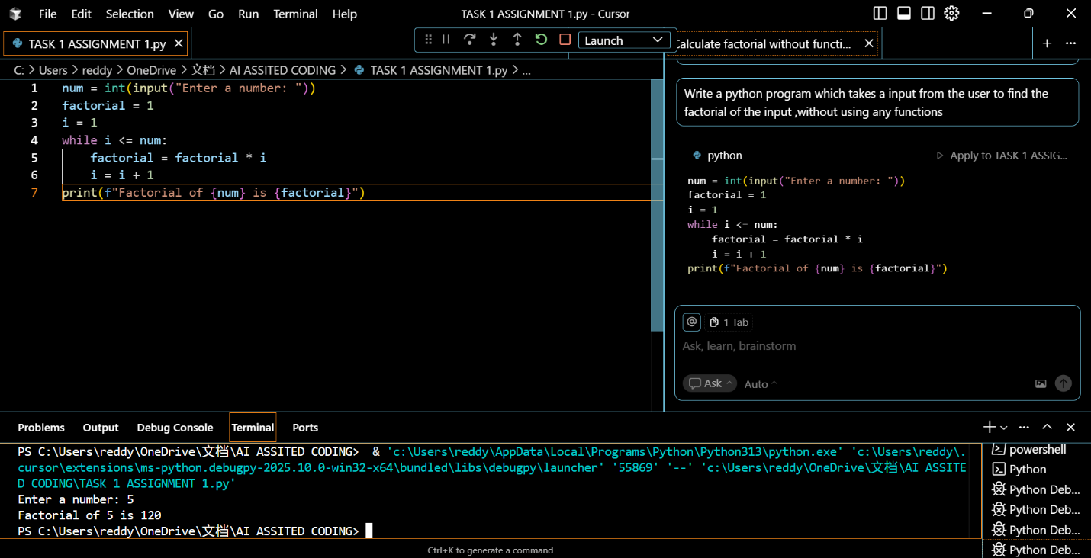

Task 2: Improving Efficiency
- Description:
Examine the Copilot-generated code from Task 1 and demonstrate how its efficiency can be improved (e.g., removing unnecessary variables, optimizing loops).
- Expected Output:
  - Original and improved versions of the code.
  - Explanation of how the improvements enhance performance.
prompt : From the above python code improve the efficiency by removing unnecessary variables,optimizing loops.

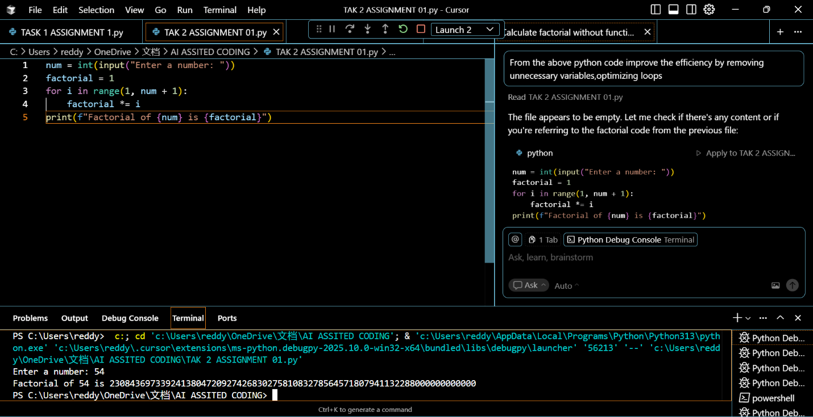

Task 3:Factorial with Functions
- Description:
Use GitHub Copilot to generate a Python program that calculates the factorial of a number using a user-defined function.
- Expected Output:
  - Correctly working factorial function with sample outputs.
  - Documentation of the steps Copilot followed to generate the function.
Prompt :write a python program code which take the input from the user to find factorial of input by using an user defined function

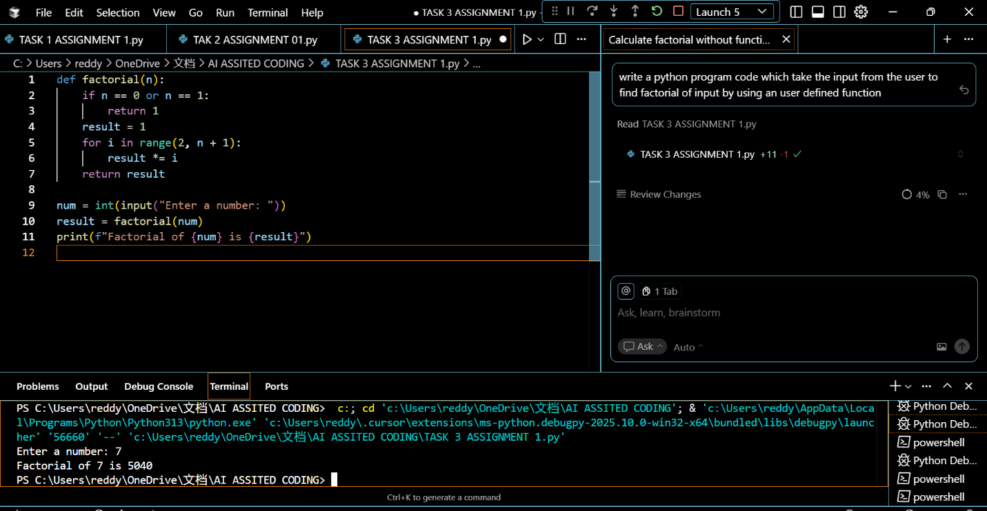

Task 4: Comparative Analysis – With vs Without Functions
- Description:
Differentiate between the Copilot-generated factorial program with functions and without functions in terms of logic, reusability, and execution.
- Expected Output:
A comparison table or short report explaining the differences

Prompt: From the above two previous codes differentiate between program with functions and without functions in terms of logic, reusability, and execution.

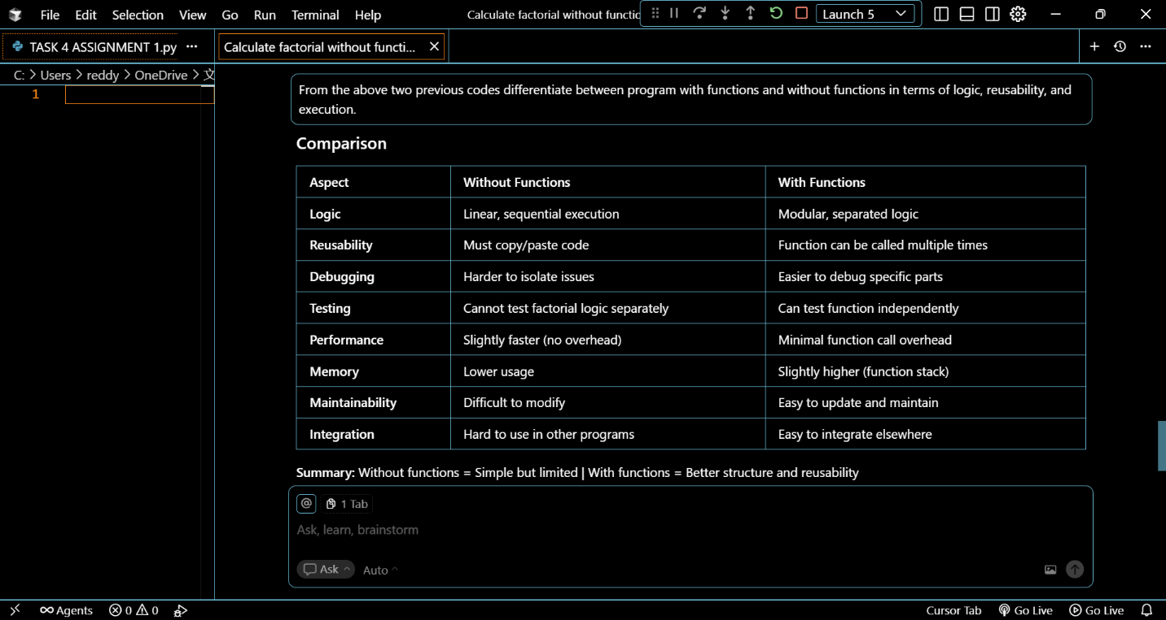

Task 5: Iterative vs Recursive Factorial
- Description:
Prompt GitHub Copilot to generate both iterative and recursive versions of the factorial function.
- Expected Output:
  - Two correct implementations.
  - A documented comparison of logic, performance, and execution flow between iterative and recursive approaches.

- Prompt : write a python program code in both iterative and recursive versions of the factorial function

